**CSC 540 - Database Management Systems**

**Project Report 1 - Corrections**

WolfHospital Management System

**Sections Covered:**

1. Application Program Interfaces
2. Local ER Diagrams
3. Local Relational Schemas

Team Members:

Mohd Sharique Khan (mkhan8@ncsu.edu)

Richa Dua ([rdua2@ncsu.edu](mailto:rdua2@ncsu.edu))

Siddu Madhure Jayanna (smadhur@ncsu.edu)

Viviniya Alexis Lawrence (palexis@ncsu.edu)

*The changes are highlighted in the document. The ER Diagram changes are shown in green.*

1. **Application Program Interfaces:**

**Information processing:**

***createStaff***(name, age, gender, jobTitle, professionalTitle, department, phoneNo, address)

return staffID or NULL(error)

***createPatient***(SSN, name, DOB, gender, phoneNo, address, status)

return patientID or NULL(error)

***createWard***(capacity, charges)

return wardNO or NULL(error)

***updateStaff*** *(*staffID*, <attribute(s)>*)

return success or failure (error)

· staffID and atleast one attribute(name, age, gender, jobTitle, professionalTitle, department, phoneNo, address) mandatory

***updatePatient*** *(*patientID*, <attribute(s)>*)

return success or failure (error)

· patientID and atleast one attribute(SSN, name, DOB, gender, phoneNo, address, status) mandatory

***updateWard***(wardNO, *<attribute(s)>*)

return success or failure (error)

· wardNO and atleast one attribute(capacity, charges, staffID) mandatory

***deleteStaff*** *(*staffID*)*

return success or failure (error)

***deletePatient*** *(patientID)*

return success or failure (error)

***deleteWard***(wardNO)

return success or failure (error)

***checkBedAvailability***(wardNO/capacityType)

return bedNO or NULL (no bed available)

· Availability check can be done for ward or capacityType (1-bed, 2-bed, and 4-bed ward)

· If both are not provided, returns any available bed.

***assignBed***(wardNO, BID, patientID)

return success or failure

· wardNO, patientID, and bedNO are mandatory

***reserveBed***(wardNO,bedNO)

return success or failure

***releaseBed***(wardNO,bedNO)

return success or failure

**Maintaining medical records for each patient:**

***createMedicalRecord***(patientID, startDate, staffID)

return a MedicalRecordId or NULL (error)

***updateMedicalRecord***(MedicalRecordId, <attributes>)

return success or failure

· The attributes can be medications prescribed, tests, diagnosisResults, endDate

***createCheckIn***(bedNo, patientID, startDate, endDate)

returns success or failure

***updateCheckIn***(patientID, startDate, <attributes>

returns success or failure

· Attributes can be endDate, bedNO

**Maintaining billing accounts:**

***createBillingRecord***(patientID,consultationFee,payeeSSN,billingAddress,paymentMethod,cardNumber,visitDate, needCheckIn)

returns billingRecordId or null (Error)

· needCheckIn is used to check for bed availability

***updateBillingRecord***(billingRecordId,<attribute1>,<attribute2>)

returns success or failure

· attribute1 can be consultationFee, payeeSSN, billingAddress, paymentMethod, cardNumber, visitDate, medicationPrescribed, testName

· if attribute1 is medicationPrescribed, testName, an attribute2 which is cost should be provided.

***getMedicalRecordForPatient***(patientID, startPeriod, endPeriod)

returns a list of medicalRecords or NULL (error)

· if startPeriod and endPeriod is null, entire record list is returned

**Reports:**

***getMedicalRecordForPatient***(patientID, startPeriod, endPeriod)

returns a list of medicalRecords or NULL (error)

· if startPeriod and endPeriod is null, entire record list is returned

***getBedUsage***()

returns a list of beds or NULL (error)

· the Bed Object would have the associated Ward number and AvailabilityStatus.

***getPatientCount***(isUnique)

returns count or 0 (error)

· isUnique is optional, when set to true returns distinct count of patients visited per month

· The count would be returned based on Billing Record visit date.

***getWardUsage***()

returns percentage or 0 (error)

***getPatientListFor***(staffID)

returns List of Patients or NULL (error)

***getStaffList***()

returns List of Staff grouped by roles or NULL(error)

1. **Local ER Diagrams:**

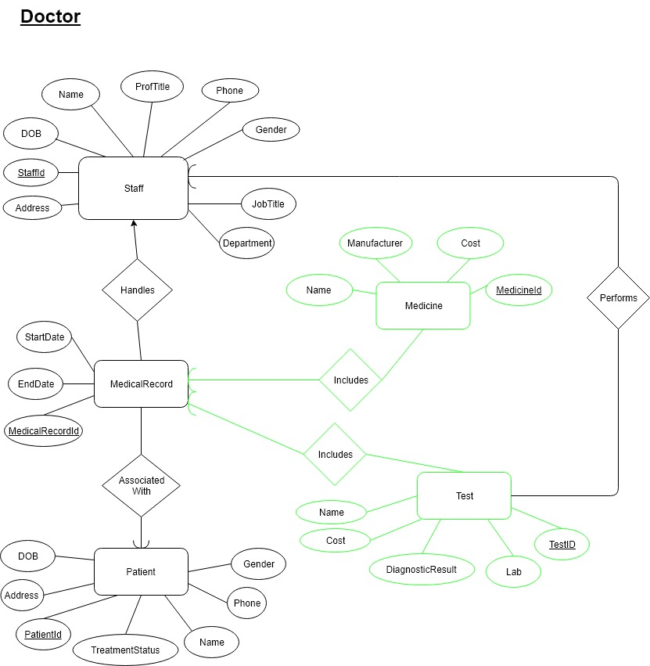

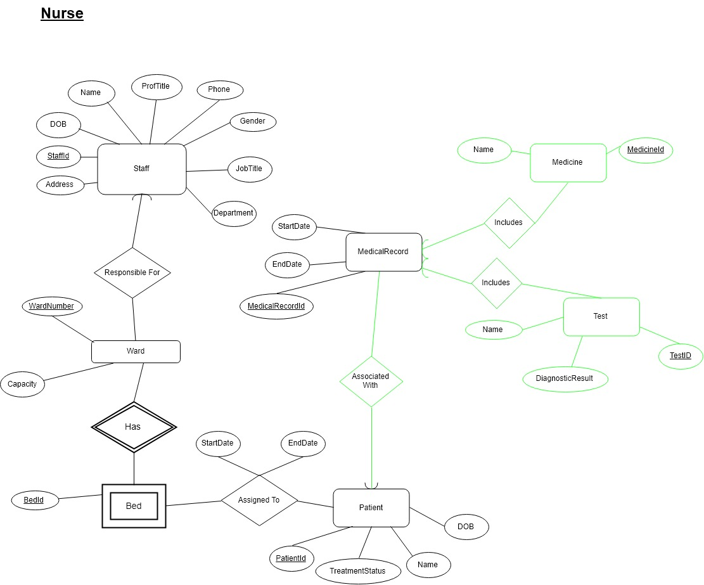

**Registration Staff:**

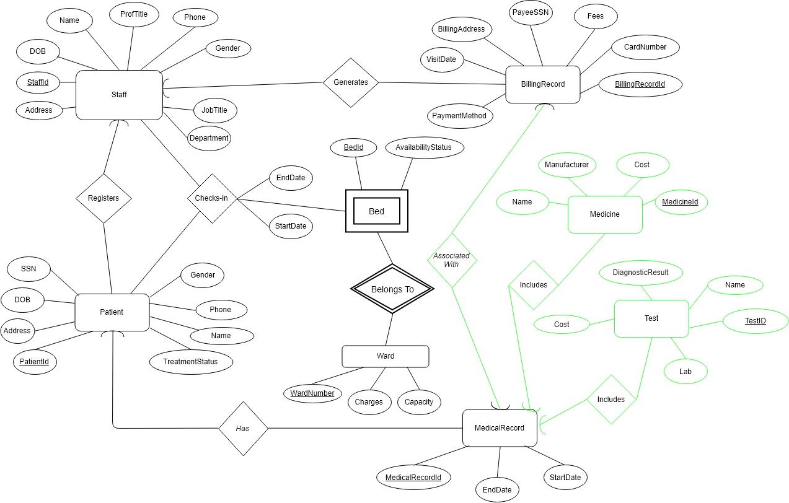

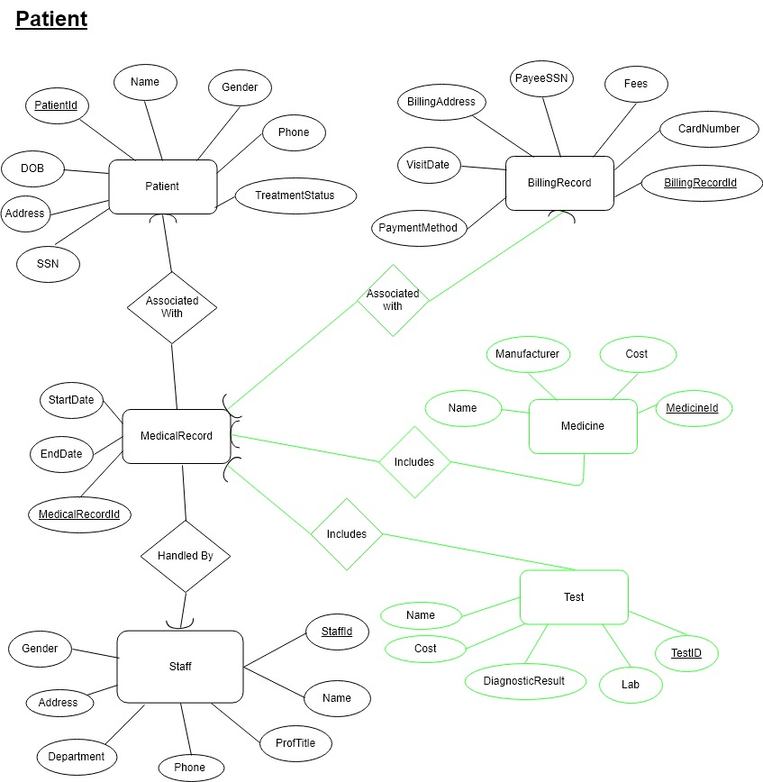

1. **Local Relational Schemas:**

**Doctor**:

Staff(StaffId, Address, DOB, Name, ProfTitle, Phone, Gender, JobTitle, Department)

Patient(PatientId, DOB, Address, Name, Phone, Gender, TreatmentStatus)

MedicalRecord(MedicalRecordId, StaffId, PatientId, StartDate, EndDate)

Medicine(MedicineId, Name, Cost, Manufacturer, MedicalRecordId)

Test(TestId, Name, Cost, DiagnosisResult, Lab, StaffId, MedicalRecordId)

**Nurse**:

Staff(StaffId, Address, DOB, Name, ProfTitle, Phone, Gender, JobTitle, Department)

Patient(PatientId, DOB, Name, TreatmentStatus)

Ward(WardNumber, Capacity, StaffId)

Bed(BedId, WardNumber)

AssignedTo(BedId, WardNumber, PatientId, StartDate, EndDate)

MedicalRecord(*MedicalRecordId*, PatientId, StartDate, EndDate)

Medicine(MedicineId, Name, *MedicalRecordId*)

Test(TestId, Name, DiagnosisResult, *MedicalRecordId*)

**Registration/Billing Staff**:

Staff(StaffId, Address, DOB, Name, ProfTitle, Phone, Gender, JobTitle, Department)

Patient(PatientId,SSN, DOB, Address, Name, Phone, Gender, TreatmentStatus, StaffId)

MedicalRecord(MedicalRecordId, PatientId, StartDate, EndDate)

BillingRecord(BillingRecordId, StaffId, MedicalRecordId,PaymentMethod, CardNumber, Fees, PayeeSSN, VisitDate, BillingAddress)

Medicine(MedicineId, Name, Cost, Manufacturer, MedicalRecordId)

Test(TestId, Name, Cost, DiagnosisResult, Lab, StaffId, MedicalRecordId)

Ward(WardNumber, Charges, Capacity)

Bed(BedId, WardNumber, AvailabilityStatus)

ChecksIn(BedId, WardNumber, PatientId, StartDate, EndDate, StaffId)

**Patient**:

Staff(StaffId, Address, Name, ProfTitle, Phone, Gender, Department)

Patient(PatientId,SSN, DOB, Address, Name, Phone, Gender, TreatmentStatus)

MedicalRecord(MedicalRecordId, PatientId, StartDate, EndDate, StaffId)

BillingRecord(BillingRecordId, MedicalRecordId, CardNumber, Fees, PayeeSSN, PaymentMethod, VisitDate, BillingAddress)

Medicine(MedicineId, Name, Cost, Manufacturer, MedicalRecordId)

Test(TestId, Name, Cost, DiagnosisResult, Lab, MedicalRecordId)